How to find the firmware of your smart plug in the Beli app

Step1: Log into Beli app, then tap your device.

Step2: Tap the “three dots” icon on the top right corner.

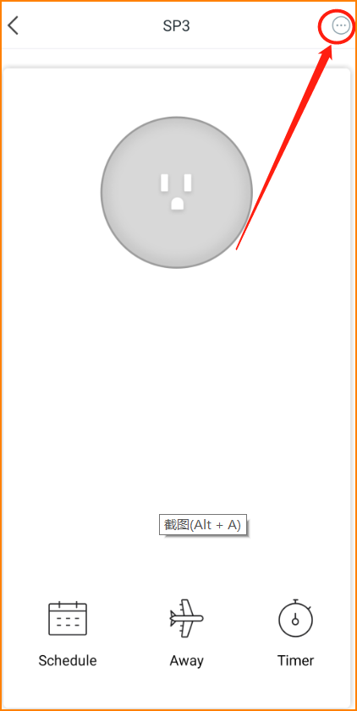

Step3: Slide down to the button you could find the firmware of your smart plug.

